MESSAGE FOR FAMILIES ABOUT THE PLEDGE
[Date]
Dear Families:
Our school believes that all children deserve the opportunity to be healthy and successful. Healthy eating and physical activity improve concentration, memory, and mood, helping students become better learners.
To support healthy students and families, we have taken the Jump IN Pledge for Schools and will do our part to help students make healthy choices:
- We will serve healthy meals and beverages in our cafeteria.
- We will promote healthy snacks in our classrooms, vending machines, concession stands and fundraisers.
- We will ensure that our students are physically active for at least 30 minutes during the school day.
- We will teach our young people to make healthy choices to eat nutritious foods and be physically active.
- We will encourage parents and caregivers to promote healthy habits at home.
We are joining other schools, child care providers, youth organizations and out of school programs in promoting the 5-2-1-0 Every Day message:
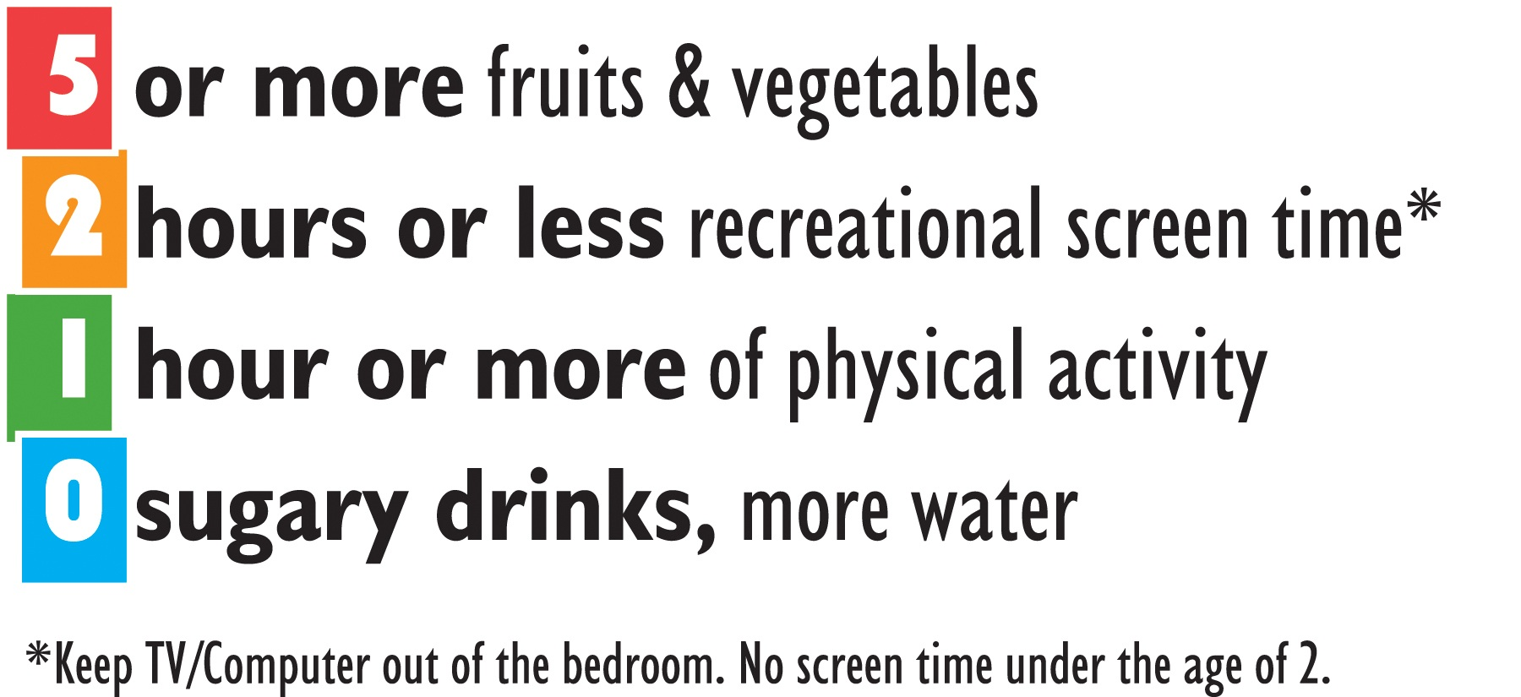
Your student will receive more information about 5-2-1-0 throughout the year. If you have any questions please don’t hesitate to contact us. If you would like more information about the Jump IN Pledge visit www.JumpInPledge.org. Thank you for your support in helping us create a healthier place for our students to learn!
Sincerely,

